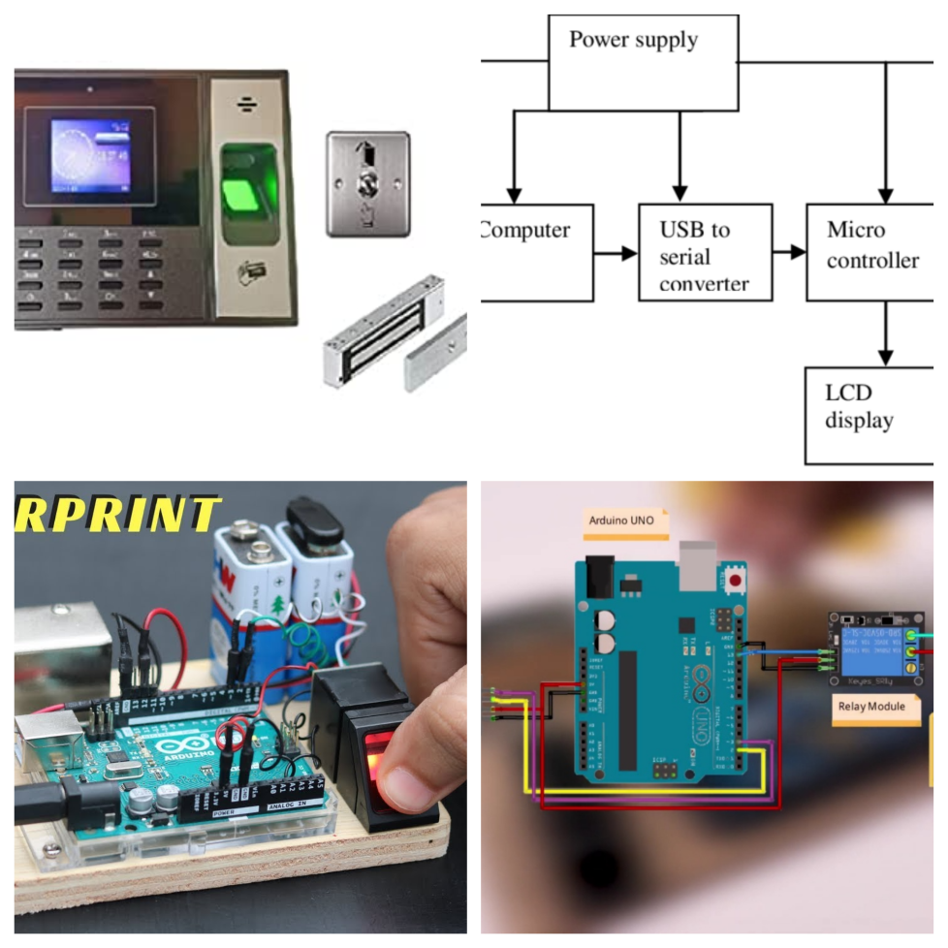

**FINGERPRINT BIOMETRICS**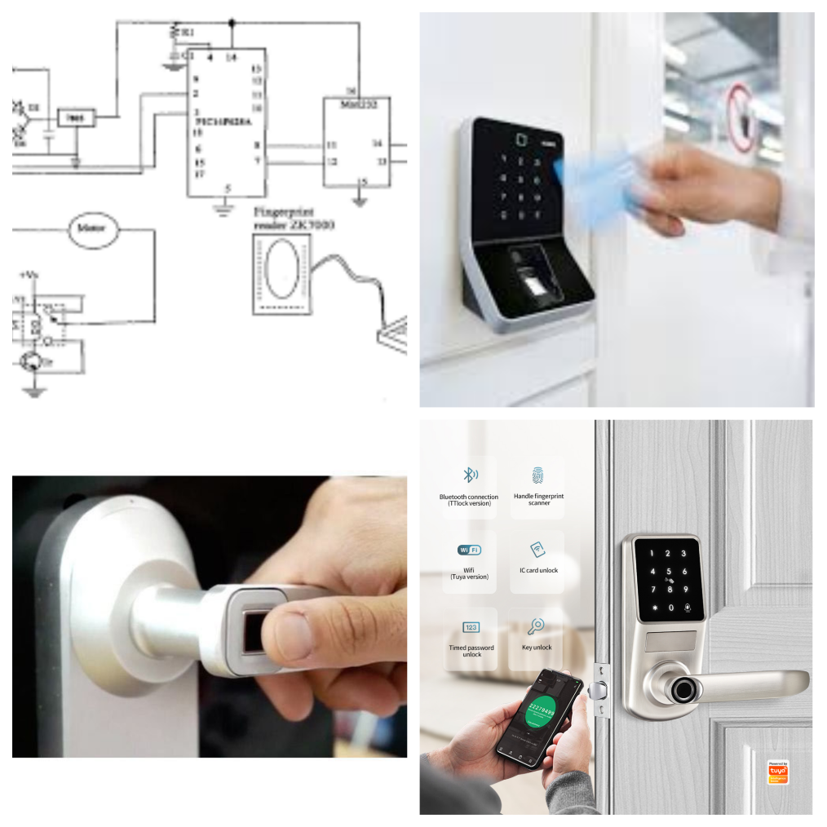

**ABSTRACT:**

Arduino integrates both software and hardware components where the hardware works based on the code that is received as input. It has varied applications in day-to-day life. My idea of fingerprint door lock system was introduced as an alternate to physical lock and key system. The physical lock and key was identified to be a drawback because of thefts, duplication and other security issues. The fingerprint sensor provides higher automation and security features by identifying the users unique physical and behavioral characteristics(biological traits). These gadgets are now available in a comparatively cheaper cost. The fingerprint sensor will take the fingerprint of the user and forward it to the microcontroller to match with its records. If the print matches with one of the fingerprints of the microcontroller’s memory, the microcontroller will lock or unlock the latch, based on its current state. No change is observed if the fingerprint does not match the memory. The system will be reset once a known print will be entered. A total of 50 fingerprints can be stored manually. It is automated and no manual entry of users is required as it is stored as a memory in the storage unites like RAM, ROM, EPROM. The sensor, lock and Arduino Uno kit are interconnected which helps in sensing the biometrics. Initially, fingerprints are stored in the memory by connecting it to pc for coding and later they are verified to open or close the lock.